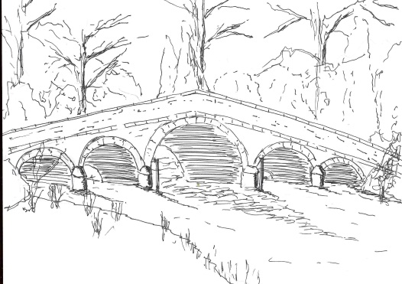 385
Skerne and Wansford Parish Council

Church Cottage, Wansford, Driffield, YO25 8NT
e-mail: jill_pick2001@yahoo.co.uk
tel: 01377 254741
Minutes of an extraordinary meeting of the Skerne and Wansford Parish Council which took place at 7.30pm on Tuesday February 23 2021 remotely via Zoom

- Present: Couns Ian Lamble, Jackie Dobson, Gill Grassam, Lynn Stockwell, Ann Kitching (via WhatsApp), Mark Padgett, Neil Robson, Caroline Harrison and Catherine Bristow.

- Apologies: None

- Public session: No members of the public present

- Declarations of interest: None

- Resolved: to confirm the minutes of the meeting on January 19 2021 as a true and correct record: proposed Coun Grassam, seconded Coun Bristow

- To dispose of any business remaining from the previous meeting and, if necessary, decide on a course of action:
- Clerk vacancy. It was agreed that, owing to the lack of interest in the position, the clerk would stay on in a caretaker role until March 2022 at the latest with the post being advertised in June when, hopefully, the Covid 19 Government restrictions were to be lifted.
- Planning:
- To respond to the following planning applications: 21/000467/hedge: removal of poor quality hedge on land east of Field House Farm, Driffield Road, Skerne. Applicant: Mr Nicholas Minns. 21/00216/STPLF: No comment. Change of use of land and excavation works to create access from Driffield Canal and create a 22-berth marina for mooring leisure boats with associated access track and car park. Members broadly welcomed the application feeling that it may have economic benefits for the area. However, concerns were expressed about increased levels of traffic and the nature of the occupancy of the boats. While members were aware of an impending road safety initiative cutting the speed limit to 50mph on that section of road, it was agreed that a request be made of the ERYC that the 30mph speed limit, which ends near the Trout Inn, be extended as far as the proposed marina access. Members also requested that a condition be imposed that the boats be for pleasure/leisure breaks only and not for permanent occupancy.

- Finance:
- Noted: Bank balances at January 31 2021: Active saver, £1,281.69, Business a/c £4,100.93. Total £5283.62.

- Date of next meeting: March 16 2021 at 7.30pm via Zoom.

