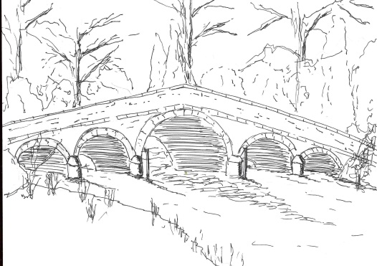
Skerne and Wansford Parish Council

Church Cottage, Wansford, Driffield, YO25 8NT
e-mail: jill_pick2001@yahoo.co.uk
tel: 01377 254741
You are summoned to a meeting of the Skerne and Wansford Parish Council to take place on Tuesday September 24 2019 in Wansford Village Hall at 7.30pm.

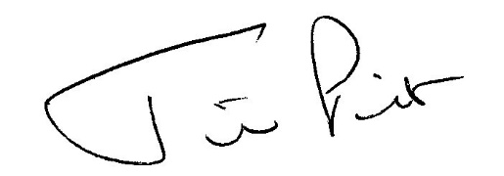

Mrs Jill Pick
Clerk, Skerne and Wansford Parish Council
Church Cottage, Wansford
e-mail: Sandwpclerk@yahoo.co.uk Tel: 01377 254741

September 9 2019

AGENDA

- Present:

- Apologies:

- Public session: At this point the meeting may be suspended for no more than 15 minutes for members of the public to make representations to the council. No one member of the public may speak for more than five minutes. Immediately after the public session the meeting will be resumed.

- Declarations of interest:

- To confirm the minutes of the meeting on July 16 as a true and correct record:

- To dispose of any business remaining from the previous meeting and, if necessary, decide on a course of action:
- Skerne community space, public meeting, survey, committee/working party
- Emergency plan – updated and despatched to County Hall
- Swimming in the canal
- To note minutes of parish and town council liaison meeting have been circulated
- Planning:
- To note to the following planning applications: 19/02653/OUT. Erection of two dwellings and conversion of cart shed to dwelling following demolition of farm buildings. Applicant I Pick & Sons.
To ratify decision to object (as per Standing Order 15b xv and following council-wide consultation) pending clarification regarding parish assets situated in/near the proposed new access and highlight once again the unsuitability of The Square as a farm access. 19/02567/PLF. Change of use of agricultural land at Skerne to provide an area of public open space. Applicant: Skerne and Wansford Parish Council.

- Finance:
- To ratify payment of £11.32 regarding electricity to the Skerne defibrillator.
- Resolve to ratify clerk’s salary for 2020-21 as per recommendation of personnel committee with a view to setting a budget
- Resolve to consider parish grant applications for 2020-21 with a view to setting a budget
- To consider any other outlays for the coming financial year with a view to setting a budget
- To consider replacement of the picnic bench on Wansford Lock with the ring-fenced funds from Driffield Canal Partnership with a view to setting a budget
- To ratify reimbursement to clerk of £251 for planning application fee
- To ratify reimbursement to clerk of £15 for Alma Printers for survey forms
- To note that Information Commissioner fee of £35 has been paid by direct debit
- Bank balances as at July 31 2019, current account £2,674.73 (less unpresented cheque of £11.32 equals £2,663.41 actual figure); business savings account £3,275.29. August statement not received to date.

- Administration and training:
- ERNLLCA: Good Councillor Guide, printed editions available at £3.35 per copy plus £1.20 handling fee and postage and packing costs.

- Correspondence:
- Terry Jarvis: letter re Wansford kiosk, what he is hoping to achieve and various payments.
- Orsted: newsletters and consultation
- Conservative Group: East Wolds and Coastal cluster meeting, October 10 at 6.30pm in Foston Village Hall, circulated
- Lissett Wind Farm home security fund, circulated
- Humberside Police, community speedwatch, circulated
- Humberside Police and Crime Commissioner: meet the commissioner events, circulated.
- City Healthcare Partnership: free defibrillator training

- Highways:

- Other correspondence:

- To receive reports from representatives:

- Items for next agenda:

- Date of next meeting:

