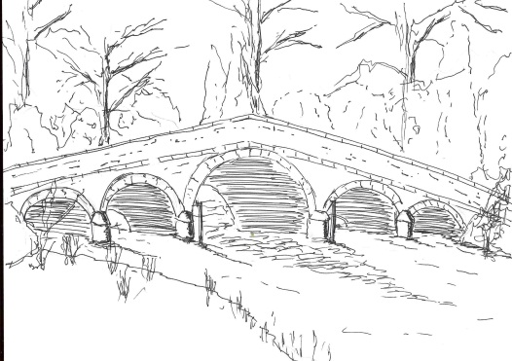
Skerne and Wansford Parish Council

Church Cottage, Wansford, Driffield, YO25 8NT
e-mail: jill_pick2001@yahoo.co.uk
tel: 01377 254741
368
Minutes of a meeting of the Skerne and Wansford Parish Council which took place on Tuesday July 16 2019 in Wansford Village Hall at 7.30pm.

- Present: Councillors Jackie Dobson (in the chair), Gill Grassam, Lynn Stockwell, Caroline Harrison, Neil Robson, John Warden, Ann Kitching and Catherine Bristow, ERY councillors Jonathan Owen and Jane Evison.

- Apologies: Coun Ian Lamble

- Public session: No members of the public present. The matter of new legislation regarding septic tanks had been raised at the last meeting. Couns Evison and Owen had had a meeting with the Environment Agency which they felt was totally unprepared and had been given no instructions regarding the legislation’s implementation and was waiting from guidance from Defra. They had taken the matter to the ERYC Overview and Scrutiny committee as a matter of urgency in an attempt to discover some answers. A charity, North, East and West Yorkshire Groundworks could give advice on the issue.

- Declarations of interest: None

- Minutes of the meeting on May 21: accepted as a true and correct record.

- To dispose of any business remaining from the previous meeting and, if necessary, decide on a course of action:
- Skerne community space – members decided that the survey be circulated in Skerne and a public meeting be held in Skerne Church on Monday September 9 at 7.30pm. Resolved: to have the survey printed at Alma Printers, proposed Coun Kitching, seconded Coun Grassam. Resolved: to apply for change of use of the area in question, including an extension to the footpath, Resolved: to pay for any necessary searches involved in the land transfer. Proposed Coun Stockwell, seconded Coun Warden. Noted that vice-chairman Coun Dobson had had a preliminary meeting with Gemma Foster.
- Dog fouling in both villages. This was an ongoing issue in both villages.
- Sat Nav: Noted: the clerk had contacted the Satnav companies and informed them of the concerns re Back Lane, Skerne. Agreed: that the clerk contact Paula Parker re the re-positioning of the weight restriction sign in Back Lane to make it more prominent.
- Wansford kiosk: nothing to report.
- Wansford bench and Skerne noticeboard: work completed.
- Parish and town council liaison meeting attended by Coun Warden. There had been a mundane discussion regarding the planning process and guidelines for permitted development. The clerk to circulate the minutes when they arrived.
- Noted: that Malcolm Jordan, an experienced bookkeeper, has kindly agreed to be the internal auditor.

- Finance:
- Resolved: to pay B & C H Walker, North Frodingham, £54.48 inc £9.08 VAT, for replacing faulty photo cell on Skerne defibrillator. Deferred: the light sensor on the Skerne defibrillator was on the meter which had been installed within a laurel bush. Billy Waites had been concerned that this may be causing the light to come on too early and go off too late and had suggested that the sensor could be relocated near to the light. However, when the meter had been read the cost of the electricity used was down substantially on the previous year. Agreed: to defer any decision about relocating the sensor until next year and monitor the situation.
- Noted: that £35 data protection fee will be paid by direct debit to the Information Commissioner on July 21
- Received: bank reconciliation as at June 30.

- Administration and training:
- Resolved: to authorise chairman Ian Lamble, vice-chairman Jackie Dobson and Lynn Stockwell to be signatories for the parish council as per the authorised cheque signatories.
- Noted: that the external auditor PFK Littlejohn has accepted the parish council as an exempt authority
369
- Noted: that the water pump and grit spreader are now situated at Leylandii, Skerne
- Noted: Coun Warden had agreed to be on the Emergency Plan, which was being updated.
- ERNLLCA: Possible Being A Good Councillor training in September – time and venue to be fixed. E-mails circulated. Any councillors wishing to attend would contact the clerk

- Correspondence:
- Noted: Orsted: Hornsea Four community newsletters
- Couns Evison, Owen and Lisseter: Ascertaining interest and topics for a parish councils cluster meeting later in the year. Coun Kitching expressed an interest in attending. Topics included dog fouling and septic tanks.

- Highways: A bag of brash and grass clippings had been left over a drain near The Haven. Coun Stockwell would report this on the ERYC website.

- Other correspondence: None.

- To receive reports from representatives: Feoffees – nothing to report. DNAA – nothing to report. However, children were still continuing to swim in the lock and the canal. Various health and safety issues were raised about this and it was decided that another letter be sent to the Driffield Navigation Trust requesting that sign be placed on the lock forbidding swimming there. Resolved: to send a press release to the local paper pointing out the dangers of swimming in the canal.

- Items for next agenda: Skerne community space.

- Date of next meeting: September 24. Personnel committee meeting to start at 7.15pm.

