Driffield & Rural Ward and
East Wolds & Coastal Ward Update for August 2019

- CRIME AND ASB

Driffield and Rural Ward –

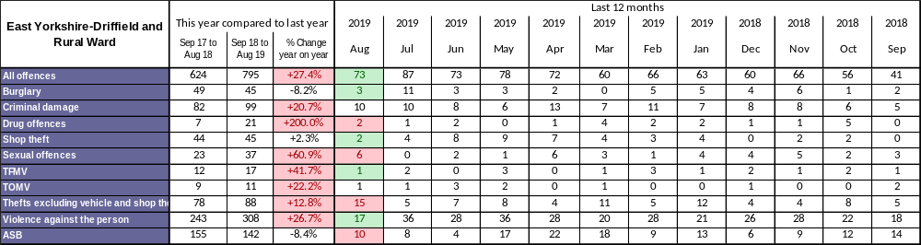

For the time of year, an improved picture; Violence against the person is at 17 instances this month. There is no particular pattern to this but has a lot to do with the time of year and good weather which fuels excess in alcohol consumption and the problems this brings. There is no defence for crimes committed when drunk and we deal robustly with anyone committing violent acts whether in drink or otherwise. Theft from Motor Vehicle is down to one instance this month which is good, although we are still high compared to last year, please remember not to leave valuables eg handbags, shopping bags, mobile phones or sat navs on display as these will attract this type of crime.

East Wolds and Coastal Ward –

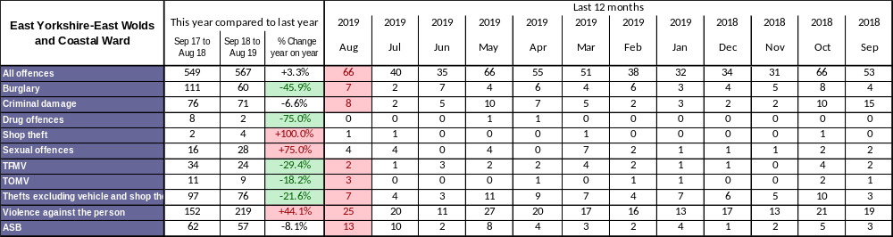

Similarly to other areas, Violence against the person has been higher this month with 25 instances of this category of offence. Again there is no particular pattern to this but as previously stated is linked to good weather and excess alcohol consumption. In the East Wolds and Coastal ward area there is a hugely increased population of holiday makers and this does have an overall impact on the figures. Visitors can be more relaxed on holiday and therefore not take the same crime prevention measures they may take at home. Sadly this can lead to them becoming a victim of crime.

Theft of Motor Vehicle. There were three instances of this type of offence which obviously affects the owners immensely, mopeds and motorcycles are in this category and they are more vulnerable to theft. Please be vigilant and lock your vehicles and use any devices to immobilise them to deter any would be-thief.

TFMV - Theft from motor vehicle TOMV - Theft of motor vehicle ASB - Anti-social behaviour

Christopher Whitehead - Neighbourhood Policing Sergeant

- Crime Issues of particular note

Over the summer period Thefts from motor vehicles and Theft of Motor vehicles are on the increase. The public should always check to see if their vehicle is locked and secured preferably parked in a well-lit area with all valuables out of sight. If possible tools should be removed from vans and keys to all vehicles stored in a secure place in the house or a building.
We are appealing for any information on suspicious activities overnight on the 13/08/2019 in the Spellowgate area of Driffield. 30 Sheds where entered on the allotments between 2100hrs on the 13th of August and 0800hrs on the 14th of August. If you noticed anything suspicious or have any information please contact Humberside Police on 101 quoting investigation 16/92669/19 or ring Crimestoppers on 0800 555 111 (you do not have to leave your name or address)
Burglaries are also a concern within the Driffield policing area, Garage’s and outbuildings are mostly being targeted. All items can be registered on the free to use IMMOBILISE website. East Wolds and Costal Ward areas can apply for a home security check through their Parish Council, Neighbourhood Watch or Local Community Policing Team.
As the crops have now been mostly gathered in the hare coursing/poaching logs are starting to increase, Driffield Community officers will be regularly patrolling the problem areas with the Wildlife Crime officers and the Local Farm Watch Community.

- What’s Happening In Your Area?

1) ASB in General – ASB continues within the town centre and North End Park area, with better weather and light nights, we are experiencing an increasing in groups of people congregating and being intimidating, sometimes drinking and causing ASB
.
2) Rural Crime – The trend generally at this time of year are towards higher value thefts from farms and rural businesses due to staff spending many hours in fields at harvest. Rural crime is tackled next month with Officers conducting drop-ins to farms and businesses to offer advice on target hardening their assets.
Fly tipping is still a focus, officers are still working alongside the East Riding Council Environmental teams to apprehend the culprits.

3) Shop Theft - With more shop front displays that may be easy to target, along with the increase in reported incidents of this type of offence mean that this is now a priority. We continue to patrol in a High Visibility manner on busy market days to deter any crime and provide support and reassurance to the public. Also with specific intelligence on any offender we are able to target individuals to apprehend them and put them before the courts. An important source of information on those people are that are involved in either stealing or selling on the stolen goods comes from the public. Please contact us or ring Crimestoppers.

- Crime Reduction / Safety Advice

Keep hare coursers out of our countryside

Hare coursing is reducing year on year in our area because of action taken by the police and the close working relationship with our rural communities.

Force Wildlife & Rural Crime Officer PC Brandon Ward said, “We have done really well together to reduce hare coursing and I don’t want that to stop.

“As the harvest is now almost completed we want to remind our communities to report anyone who they suspect is hare coursing in our countryside.

“We have been out across the Force area in recent weeks carrying out patrols to prevent and deter criminals from coming into our area.

“Hare coursers often use old 4x4s and carry lurcher-type dogs in their vehicles. If you see any vehicle being driven in a suspicious way in our countryside please call us and report your concerns.

“We have also seen a number of recent reports of illegal lamping in the area and this too is a wildlife crime we want to bring an end to.

“Poaching is a national wildlife crime priority and illegal ‘lampers’ are often involved in other criminality such as burglary and vehicle crime.

“We want you to report any suspicious activity to us, particularly in the early hours of the morning if you suspect lamping is in progress. By letting us know as it is happening we can catch offenders in the act.

“Prevention measures should be considered by landowners such as preventing easy access by vehicles to land by using obstacles, gates and other barriers. This is one of the most effective measures that can be taken to frustrate and deter these criminals.”

Please call 101 to report any suspicious activity – if you call us we will act.

For more information on how to sign up for Humberside Police Farm Watch or Country Watch schemes, or to find out about crime prevention workshops please email SPOCRuralandWildlifeCrime@humberside.pnn.police.uk

You can find rural crime prevention advice on our website: https://www.humberside.police.uk/wildlife-and-rural-crime

Follow us on social media:
Facebook/Twitter - @humberbeat
Twitter - @HPWildlifeRural

#ruralcrime #OpGalileo #OpZodiac
PROBE home security checks can be booked at the local police station or the public can contact their local parish council for information. PROBE is funded by the Lisset wind farm fund and they provide the home security equipment if needed at the property. This is only available to East Wolds and Coastal residents, however there are funding opportunities for the Driffield and Rural ward

IMMOBILISE – www.immobilise.com is a free to use property registering service, all you need is a serial number to register the item, if the item is lost or stolen when found or recovered it can be returned back to you.

Dogs die in hot cars

Although the weather is starting to cool there are still days when a dog could get into distress if left in a vehicle.



Never leave your dog alone in a car on a warm day. If you see a dog in distress in a hot car contact the police.

Many people still believe that it's ok to leave a dog in a car on a warm day if the windows are left open or they're parked in the shade, but the truth is, it's still a very dangerous situation for the dog. A car can become as hot as an oven very quickly, even when it doesn't feel that warm. When it's 22 degrees, in a car it can reach an unbearable 47 degrees within the hour.

Help a dog in a hot car

• Establish the animal's health and condition. If they're displaying any signs of heatstroke contact the police immediately.
• If the situation becomes critical for the dog and the police are too far away or unable to attend, many people's instinct will be to break into the car to free the dog. If you decide to do this, please be aware that without proper justification, this could be classed as criminal damage and, potentially, you may need to defend your actions in court.
• Make sure you tell the police what you intend to do and why. Take pictures or videos of the dog and the names and numbers of witnesses to the incident. The law states that you have a lawful excuse to commit damage if you believe that the owner of the property that you damage would consent to the damage if they knew the circumstances (section 5(2)(a) Criminal Damage Act 1971).

- Meet your officers -

Our Officers attend Police surgery meetings in your area on a regular basis and will be pleased to meet you to discuss any issues. To find meetings in your area please visit our website at www.humberside.police.uk. On the home page click on ‘About Us’ then ‘Find your community policing team’. Click on your area within the map and then press the ‘Go To Team Page’ button. At the bottom of the page you will see a list of meetings.

- News and Appeals

August has been a particular busy month for the Driffield Team due to numerous large community events in the area seeing 1000’s of visitors attend the Yorkshire Day Market, Annual Driffield Steam Rally and the Lions Raft race. Officers have been on hand to offer out crime reduction advice as well provide reassurance at these events with very positive comments and results.

Now the School holidays are coming to an end the Driffield PCSO’s will be attending the 17 Schools in the area to provide any reassurance needed.
Driffield community officers continue to visit addresses around the area doing the #Humbertalk survey, asking about crime and other concerns in your community.

Please visit our website www.humberside.police.uk for the latest news & appeals, and find out more about My Community Alert.

“My Community Alert” is a free messaging system operated by Humberside Police and Humberside Fire & Rescue Service, giving you live information about incidents happening in your area. Choose how you receive messages, by either phone or email, how often you want to hear from us and about the issues that matter to you. When something happens that you’ve told us you want to hear about, your local officer will send you the details, whether that’s notice of a road closure due to a collision or a burglar who has been caught in a nearby garden. Subscribe to My Community Alert to be the first to know about issues that might affect you or your family. Sign up for free on mycommunityaltert.co.uk to start receiving real time updates now.

- Useful information

Importance of Reporting incidents/crimes
Just a reminder that it is really important you report any crimes or suspicious incidents to us. This can be either via 999 or the 101 phone number, via our web site, or personally at a police station or to an officer in the street. Only by reporting the crime/incident can we be aware of it. Once we are aware we may not be able to do anything about it immediately but the report will form part of a wider picture which helps inform where we direct officers to patrol and focus activity. So please ….. take the time to report a crime/incident in the knowledge your time is not wasted. www.humberside.police.uk

The Neighbourhood Policing Team meet regularly with partners to ensure we have a multi- agency approach to local issues, individuals and problem solving. These meetings are regularly attended by partners including Humberside Fire and Rescue Service, Youth and Family Support, Housing Officers, Environmental Health and the East Riding Anti-Social Behaviour Team. We share information and resources to deal with local neighbourhood issues, in particular, those identified as causing the most harm in the community.

National Crime Statistics - Please look at this link to https://www.police.uk
Click on ‘Find Your Neighbourhood’ and input a post code. You can interrogate the data and get some quite specific crime information. Please be aware that the data can be a month or 2 behind.

Also follow us on www.twitter.com/@Humberbeat_ERYN



AREA COVERED BY DRIFFIELD & RURALTEAM

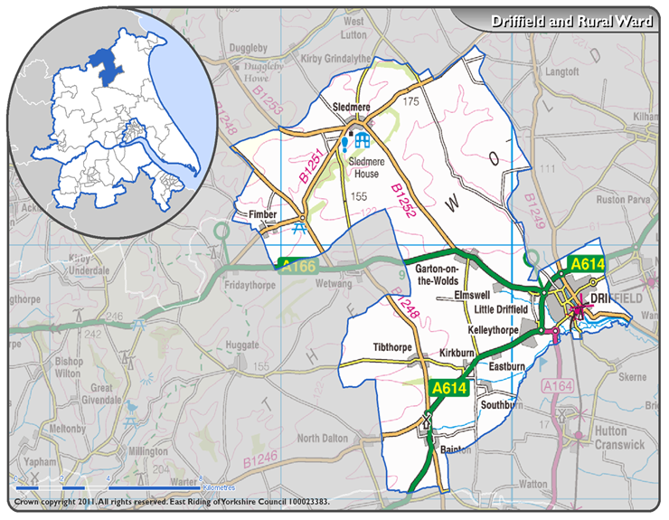

AREA COVERED BY EAST WOLDS & COASTAL TEAM



