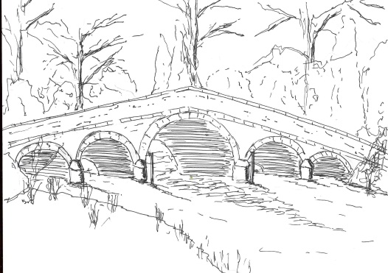
Skerne and Wansford Parish Council

Church Cottage, Wansford, Driffield, YO25 8NT
e-mail: jill_pick2001@yahoo.co.uk
tel: 01377 254741
362
Minutes of a meeting of the Skerne and Wansford Parish Council which took place on Tuesday January 15 2019 in Wansford Village Hall at 7.30pm.

- Present: Jackie Dobson (in the chair), Lynn Stockwell, Neil Robson, Ann Kitching, Catherine Bristow, Gill Grassam, Neil Robson and Caroline Harrison and ERYC councillor Paul Lisseter.

- Apologies: Ian Lamble

- Public session: No members of the public present.

- Declarations of interest: None

- To confirm the minutes of the meeting on November 20 as a true and correct record: Minutes accepted –proposed Coun Stockwell, seconded Coun Robson.

- To dispose of any business remaining from the previous meeting and, if necessary, decide on a course of action:
- Bench in Nafferton Road, Wansford. The chairman had seen one at Cranswick Garden Centre for £249. Clerk would purchase this, as long as it could be delivered. Proposed Coun Stockwell, seconded Coun Harrison.
- Spotbox speed device: agreed that the clerk should contact PCSP Chris Webster asking that this could be used in both villages at some point.
- Wansford telephone kiosk: deferred until the next meeting when the weather is better. Clerk to remind those who expressed an interest.
- Noted: that the Emergency Plan has been updated to reflect changes within the community
- Pie and pea night at the Trout Inn: Coun Harrison said she would contact the Trout Inn with a view to an even on March 29, possibly with an earlier start to attract families as well as other members of the community.

- Planning:
- Noted: the following planning appeals: 18/00057/REFUSE – erection of two storey extension to side, construction of dormer extension following creation of additional living accommodation at first floor and erection of a detached garage. Applicant: Mr and Mrs McLoughlin.
- Noted: the following planning decisions: 18/02764/STPLFE – erection of four free-range egg units and associated feeds, hardstanding and access roads on land south of Church Farm, Skerne. Applicant: Warrendale Farms Ltd. Granted subject to conditions – copies circulated electronically. 18/01638/STPLF – erection of shed over fish ponds and erection of a processing shed on land south of Whinhill Lock, Driffield. Applicant: Wansford Trout Farm Ltd. Granted subject to conditions.

- Finance:
- Noted: that the Band D precept has gone up slightly even though the precept was pegged at £4,000. This is because of increased numbers receiving a reduction on their council tax bill (explanation circulated electronically)
- Ratified: payment of £335.50 to Came & Co for insurance, proposed Coun Harrison, seconded Coun Grassam. To note that this includes a £50 administration fee, increasing the overall cost by that amount.
- Ratified: clerk’s continuing SLCC/ALCC membership total fee of £103. Proposed Coun Stockwell, seconded Coun Bristow.
- Noted: that the clerk has returned the form to Barclays Bank requesting updated information re members.
- Noted: bank balances for the month ending December 31 2018, which reconcile to cash book: Community account, £4,863.68, business savings account, £475.29, total £5338.97.

- Administration and training:
- To adopt the council Data Protection Policy, proposed by Coun Briatow, seconded Coun Stockwell.

363

- Correspondence:
- Noted: ERYC Chairman’s Awards 2019 – built heritage (single or commercial), business (under 50 and over 51 employees, community (individual and group) and sport (outstanding team/club or talented performer)
- Noted: Orsted: Hornsea 4 consultation summary report – circulated with minutes
- Mrs Janet Lester – resignation due to changed family circumstances. As an election is scheduled for May 2, it was decided to defer any co-option until afterwards.

- Highways: the Slow sign painted on the road near Pleasant Wood Farm was very faded: clerk to contact ERYC highways. The problem of dog fouling was highlighted in both villages.

- To receive reports from representatives: None

- Items for next agenda: Vacancy for a councillor, Wansford telephone kiosk, dog fouling and purchase of information postcards concerning this matter, pie and pea night.

- Date of next meeting: Tuesday March 19 preceded by annual parish meeting starting at 7.15pm.

