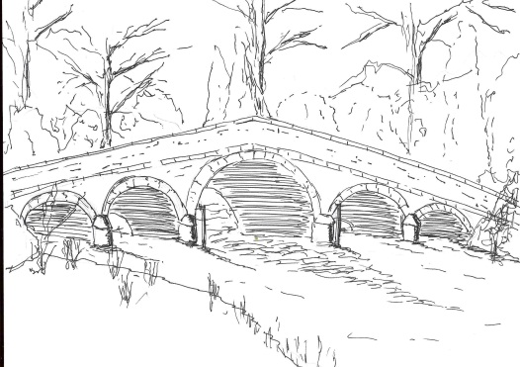
Skerne and Wansford Parish Council

Church Cottage, Wansford, Driffield, YO25 8NT
e-mail: jill_pick2001@yahoo.co.uk
tel: 01377 254741

338

Minutes of a meeting of the Skerne and Wansford Parish Council which took place on Tuesday January 17 2017 in Wansford Village Hall at 7.30pm.

- Present: Councillors Ian Lamble, Jackie Dobson, Gill Grassam, Lynn Stockwell, Ann Kitching, Catherine Bristow, Sue Waites, Caroline Harrison, Neil Robson and ERY councillors Jane Evison and Jonathan Owen.

- Apologies: none

- Public session: No members of the public present..

- Declarations of interest: None

- To confirm the minutes of the meeting on November 15 as a true and correct record: Confirmed with the replacement of Jackie Dobson as proposed and Neil Robson as seconder on item 11i. Proposed Coun Stockwell.

- To receive updates/information from ward councillors: £20,000 would be available from the Lissett Wind Farm Fund in the coming financial year from community defibrillators.

- To dispose of any business remaining from the previous meeting and, if necessary, decide on a course of action:
- Skerne drains – possible update. Back Lane - the Skerne councillors believed that a new soakaway near the entrance to Spring Farm and digging out the concrete soakaway near Well House and filling the hole with rubble would help alleviate the problem.
- Noted: A Skerne burial ground grant form has been submitted asking for £275, the sum allocated in the 2017-18 budget.
- Resolved: to confirm the precept at £3,500 and sign the forms – deadline January 20. Proposed Coun Kitching, seconded Coun Grassam.
- Noted: that insurance premium has been paid a documentation received
- Resolved: following a discussion re the new representations made since the deadline it was decided to ask the ERYC if the December decision could be changed and the Wansford kiosk adopted. Proposed Coun Stockwell, seconded Coun Harrison.
- Noted: both boxes were scheduled for painting in the coming year and will be reviewed with a view to complete renewal in the coming year, but it is unlikely that Skerne’s box will be renewed. The clerk to send Coun Waites e-mail to Royal Mail so that she could give them permission to enter her garden to do the work.
- Planters in Wansford – Coun Stockwell had plans in hand but, as yet, had made no purchases.
- Driffield Canal Steering Group meeting. This had taken place on January 16 – the group appeared to be concentrating on the museum aspect of their scheme.
- Skerne survey being conducted by Coun Kitching: people had expressed an interest in joining a committee to try to establish a play area and the church has been offered as a meeting place.
- Neighbourhood Networks. Agreed: that volunteer John Edwards, of Skerne, set up a Skerne network and ask him for a short article for the village newsletter introducing himself and asking contact details of people wishing to be in the network.

339
- Planning:
- To respond to the following planning applications: Appeal to be decided by Public Enquiry – DC/15/02780/STPLF: erection of anaerobic digestion plant and associated works on land south west of West Farm, Foston Lane, Beeford by Gascorp Delta Ltd. The parish council has previously objected to this - any comments already made will be forwarded to the Planning Inspectorate and taken into account. Coun Evison said that the ERYC was challenging the application at the appeal, which would be held in the East Riding in the autumn, The protest group would be able to participate in the proceedings.

- Finance:
- Received: a bank reconciliation: members noted that a telephone call to Barclays had indicated the figure of £4,198.82 as per the December statements included £10.51 interest that, as yet, was not showing as a separate item on any statement. The clerk had requested such a statement but Barclays had sent one for the wrong account.
- Precept (see item 7iii). Dealt with.
- Noted: that insurance premium of £275 has been paid (see item 7iv)
- Resolved: to pay for renewal of clerk’s membership of the SLCC/ALCC at £55. Proposed Coun Stockwell, seconded Coun Dobson

- Correspondence:
- ERYC Chairman’s Awards: anyone thinking a suitable recipient should contact the chairman
- Noted: ERYC Anti-social behaviour statistics – there seemed to be no instances within the parish but it was remarked that dog fouling continued to be a problem.
- Noted: ERYC Neighbourhood Planning newsletter
- St Mary’s Church PCC: request for co-operation between the two bodies re VAT reclamation concerning proposed works on village burial ground. Clerk had contacted ERNLLCA who had informed the council that the proposed collaboration was not possible.
- Coun Evison: Tour de Yorkshire route – there were two places available for councillors at the official stand in Driffield, should anyone want to take them up.

- Matters requested by councillors:
- Possible provision of some lighting on the path to Skerne church to aid dog-walkers: Skerne PCC was to do this as part of their churchyard maintenance plans.
- Resolved: a small amount of grass seed for near the plank bench at Carr Lane, Wansford, could be purchased.

- Highways:
- Renewal and possible repositioning of signpost at Main Street/West End junction. The clerk would write to ERYC Highways asking for the replacement sign to be repositioned between West End Farm and Nicholsons Farm and for the Main Street sign to be repositioned a few yards further east nearer to the Southlands gate.
- Kerbing/some measure to stop lorries mounting the footpath outside Rose Cottage, Skerne. The clerk to write to ERYC asking for some measure to stop lorries mounting the footpath at this point.
- Parked/abandoned car I n Nafferton Road: the clerk to email the PCSO to ask if there was an update regarding this vehicle, which had been in situ for a month
- Clerk to write to Rob Brown re potholes at the corner of Main Street/Church Lane, Skerne.

- To receive reports from representatives: Work on the Nafferton Recreation Club scheme had started.

Items for next agenda: Skerne telephone kiosk; A villager had suggested that the idea of nights out at the Trout be revived. At this point members indicated that the clerk, as part of her administrative obligations, was able, on behalf of the parish council, take out a four-year guarantee on the parish council laptop.

- Date of next meeting: annual parish meeting at 7.15pm, immediately followed by the parish council meeting, both to take place on March 21 at Wansford Village Hall.

