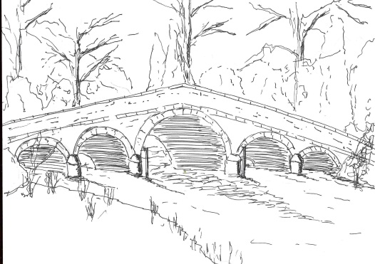
Skerne and Wansford Parish Council

Church Cottage, Wansford, Driffield, YO25 8NT
e-mail: jill_pick2001@yahoo.co.uk
tel: 01377 254741
350
Minutes of a meeting of the Skerne and Wansford Parish Council which took place on Tuesday January 16 2018 in Wansford Village Hall at 7.30pm.

- Present: Councillors Ian Lamble, Lynn Stockwell, Gill Grassam, Neil Robson, Caroline Harrison, Jackie Dobson, Sue Waites, Ann Kitching, Catherine Bristow and ER councillor Paul Lisseter.

- Apologies: None

- Public session: No members of the public present

- Declarations of interest: None

- Confirmed: the minutes of the meeting on November 21 as a true and correct record: Proposed Coun Bristow, seconded Coun Grassam

- To dispose of any business remaining from the previous meeting and, if necessary, decide on a course of action:
- Joe Brierley, of Lilleygarth, Skerne, had offered a venue for the bonfire to celebrate the World War 1 centenary. Agreed: the clerk to write thanking him for the offer and accepting.
- Skerne sports field investigations: the agent had indicated to Coun Bristow that obtaining the land was not an option.
- Findings from Land Registry re waste land at rear of old folks’ bungalows. Agreed: that the clerk write to ERYC asking that as and when the bungalows became vacant the land revert back to the ERYC with a view to a future parish council having this as a community space. The clerk to write also to Gabriel and Sonny McGreal explaining the situation.
- Wansford BT kiosk. Resolved: to adopt the kiosk, proposed Coun Harrison and seconded Coun Kitching.
- Noted: Humberside Police speed board had been used on a few occasions in Skerne and people warned. There was no possibility of a sign at Wansford roundabout, works on the culvert at Hutton Road, Skerne, were due to start following an accident in November.
- Noted: that insurance has been renewed at a cost of £280 as per resolution 349 9iv.
- Noted: the ERYC had swapped the waste bin at Wansford Lock at no charge. They had indicated that the passing place near Skerne Bridge was an unsuitable position for an additional bin.
- Finance:
- Resolved: to amend provisional precept figure of £4,500 to £4,000 due for submission to ERYC as extra bin was no longer an option for Skerne Road, ERYC were still considering provision of their own grit bin in Back Lane, Skerne, and there was an amount of salt in each village that could be used in parish bins as it would no longer go through the salt spreaders, being too wet. Proposed Coun Stockwell, seconded Coun Dobson.
- Received: bank reconciliation for month ended December 2017
- Noted: that clerk has been reimbursed £134.94 for payments made to Land Registry, £35.94; ALCC/SLCC £89 (349 9iii); SLCC training course, £10 (349 9ii).
- Noted: that ERYC invoice for £12 re dog fouling postcards has been settled
- Noted: that P K F Littlejohn has once again been appointed auditor for the parish council

- Administration and training:
- Clerk’s training course at South Cave: it had ben quite interesting and mainly concerned with bullying.

- Correspondence:
- ERYC Village Taskforce Satisfaction Survey – completed by clerk. Various ERYC departments still to report re issues raised.
- ERYC chairman’s awards: noted.
- Inland Revenue: proposed change of VAT number: noted.

351
- ERYC name bank for the villages – after e-mail consultation war memorial names for both villages have been submitted and accepted: noted.
- ERYC Consultation on ER Local Plan Draft Sustainability Appraisal Scoping Report – circulated electronically: noted.
- Anti-social behaviour statistics April-September 2017: noted.

- Matters requested by councillors:
- Items for maintenance, etc during coming year: deferred until March meeting. Resolved: that chairman could work out what was needed and make purchases. Proposed Coun Dobson, seconded Coun Stockwell.
- Border on bus shelter flower beds. Resolved: that Coun Stockwell could make the necessary purchases. Proposed Coun Grassam, seconded Coun Kitching.
- Possible purchase of a beacon subject to a suitable site: deferred pending finding a suitable site(s).

- Highways: Dangerous pothole in Driffield Road had been filled in.

- Other correspondence: Dove House Hospice: noted.

- To receive reports from representatives: Coun Harrison had been unable to go to the Nafferton Feoffees meeting as it clashed with parish council.

- Items for next agenda: Working party to refurbish noticeboards, benches, etc. Clean-up day.

- Date of next meeting: March 20 at 7.30pm to be preceded by annual parish meeting at 7.15pm.

