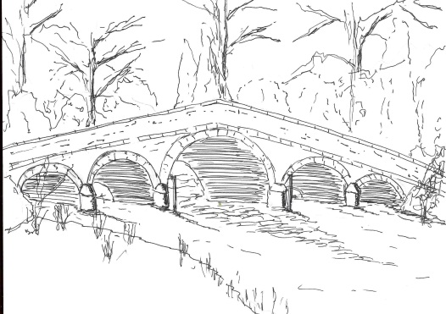
Skerne and Wansford Parish Council

Church Cottage, Wansford, Driffield, YO25 8NT
e-mail: jill_pick2001@yahoo.co.uk
tel: 01377 254741
You are summoned to an extraordinary meeting of the Skerne and Wansford Parish Council to take place via Zoom on Tuesday July 14 at 7.30pm.
Mrs Jill Pick
Clerk, Skerne and Wansford Parish Council
Church Cottage, Wansford
e-mail: Sandwpclerk@yahoo.co.uk Tel: 01377 254741

July 6 2020

AGENDA

- Present:
- Apologies:
- To confirm the minutes of the meeting on March 17 2020 as a true and correct record:
- Election of a chairman and vice chairman acceptance of office forms to be delivered subsequently
- Finance:
- To consider the council from declaring itself exempt from sending the completed Annual Governance and Accountability Return (AGAR) to the external auditor and, subject to the decision, to return the certificate to the external auditor
- To review the effectiveness of the internal control system
- To resolve to complete and approve the annual governance statement
- To resolve to approve the annual accounting statement
- To accept the statement of variances for the year and the year-end bank reconciliation
- To note that Mr Malcolm Jordan very kindly carried out the internal audit and consider sending a vote of thanks
- To ratify payments of £100.80 to ERYC for salt bin maintenance; parish grants of £275 each to Wansford Village Hall and both Skerne and Wansford churches for burial ground maintenance; £20 for Easily subscription renewal (website domain name); of £79.48 made up of £70 for Wansford Village Hall hire and £9.48 electricity to defibrillators; of ERNLLCA subscription of £285.37; £229.99 inc £38 VAT cost of new printer with eco inkwell; £47 land registry fees re transfer of Skerne land; £84 to Walkers Electrical Engineers regarding relocation of light sensor to Skerne defibrillator and £35 fee to the Information Commissioner by direct debit later in the month.
- Administration and training:
- To approve the non-attendance of members of the authority at meetings until May 2021

- Highways:
- Planning: To respond to the following planning applications: 20/00989/VAR – removal of agricultural occupancy condition at Manor Lodge, Wansford. Applicant, Mr I Pick. To note no comment response following e-mail consultation.
- Date of next meeting:

Please note that the meeting will be held via Zoom and last no more than 40 minutes. The personal meeting ID is 442 391 8889
The password is Virus2020

If by any chance it doesn’t work (fingers crossed it does), I will send you all an email invitation which will contain a meeting ID and password.

One parish councillor may be joining via Whatsapp.

