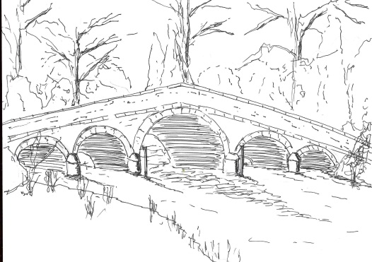
Skerne and Wansford Parish Council

Church Cottage, Wansford, Driffield, YO25 8NT
e-mail: jill_pick2001@yahoo.co.uk
tel: 01377 254741
340
Minutes of a meeting of the Skerne and Wansford Parish Council held on Tuesday March 21 2017 in Wansford Village Hall at 7.30pm.

- Present: Councillors Ian Lamble, Gill Grassam, Lynn Stockwell, Jackie Dobson, Ann Kitching, Sue Waites, Catherine Bristow, Neil Robson, Caroline Harrison and ERY Councillors Paul Lisseter.

- Apologies: ERY Councillors Jane Evison and Jonathan Owen

- Public session: No members of the public present.

- Declarations of interest: Coun Bristow re item 7i

- To confirm the minutes of the meeting on January 17 2017 as a true and correct record: Proposed Coun Stockwell, seconded Coun Bristow.

- To dispose of any business remaining from the previous meeting and, if necessary, decide on a course of action:
- Skerne telephone kiosk: Community Heartbeat secretary Martin Fagan had asked for the name of a handyman who may fix the Skerne kiosk door. Nick Madden and Richard Thomas had been suggested. Members decided they did not want a presentation on the future of the kiosk by Mr Fagan. Community Heartbeat had taken over all redundant, unadopted kiosks with a view to enlisting parish council support to put a defibrillator in each one.
- Enhancement scheme: Resolved: to reimburse Lynn Stockwell £71 for plants for the planters in Driffield and Nafferton roads. Proposed Coun Dobson, seconded Coun Bristow.
- Wansford telephone kiosk – update from ERYC: BT would be in touch in due course re the adoption of the kiosk.
- Precept figures: noted.
- Village nights out at the Trout: following a request from a member of the public it was decided to relaunch village nights out at The Trout Inn, possibly twice a year, starting on Friday April 21 at 8pm. The clerk to contact landlord Keith Robinson.
- Parked car in Nafferton Road: PCSO Chris Webster had said that this was now in hands of the ERYC.
- Four-year guarantee on pc laptop: documentation arrived – noted.

- Planning:
- To respond to the following planning applications: Erection of two storey extension to side, installation of roof lights and erection of detached garage. 17/00543/PLF. Applicant: Mr and Mrs Bristow. No comment.

- Finance:
- Resolved: to pay clerk annual salary of £1,275 less £255 tax ie £1020 net. Proposed Gil Grassam, seconded Lynn Stockwell.
- Resolved: to ratify payment clerk’s tax liability of £255 to HMRC. Proposed Sue Waites, seconded Gill Grassam.
- Resolved: to reimburse clerk £46.95 for three cartridges, a ream of paper and a notebook. Proposed Gill Grassam, seconded Jackie Dobson.
- Noted: that a VAT reclaim had been submitted for £103.99
- Noted: receipt of £30 regarding charges for paper and printing re printing of three 54-page genealogy reports concerning Pte Henry Parker for relations and interested parties had been issued.
- Noted: bank reconciliation to February 28 2017
- Received: Bank reconciliation

341
- Correspondence:
- ERYC Senior Transport Office Jason McLeavy – launch of community transport strategy on March 24: clerk to attend.
- ERYC: Village Taskforce walkabout on July 3. To be on next agenda.
- Melvyn Pack, DNA consultant to MoD regarding Pte Henry Parker, who remains have been discovered and identified and are to be buried with full military honours in France in May. Resolved: to spend up to £50 on a reath/wreaths for the funeral and, possibly for the visits of the village representatives to the graves of George Watts and Cecil Ullyott. An appeal for contributions to be placed in the newsletter. Proposed Gill Grassam, seconded Jackie Dobson.
- ERYC ward councillors: presentations to parish councils regarding areas of common concern on parochial matters. Clerk to write and highlight potholes, gullies, flooded roads, dog fouling and broadband.
- ERNLLCA: Governance and accountability re annual return, regardless of any exemption from submitting a form to the external auditor. Noted – Coun Dobson took the information.

- Matters requested by councillors and members of the public:
- Provision of a litter bin in the Skerne bridge layby at Wansford; provision of dog dirt bins: bins were £272.16 plus VAT and it would be difficult to decide where they would go as littering was widespread. This to be put on the agenda of the budget meeting.
- Village clean-up day: This was scheduled for 10am on April 8 and to be advertised in parish newsletter.
- Library Theatre: had contacted Coun Dobson concerning another performance at Wansford. Coun Dobson would contact the library theatre suggesting September 16 as a provisional date and possibly John Godber’s Happy Jack. The clerk to write to the Wansford Village Hall committee suggesting another collaboration.
- Hedge trimming between Croft Garth and Rose Farm: this had been done.
- Verge in Carr Lane: a complaint had been made about the management of the verge in Carr Lane, most of which is in Nafferton parish. Noted.

- Highways: The clerk to write to Rob Brown re the gully outside Rowan, Wansford, and potholes near the Church Lane/Wansford Road junction, Skerne; the east side of Driffield Road, Skerne, opposite Thornsett; the west side of the same road opposite Skerne Leys entrance.

- Other correspondence: None.

- To receive reports from representatives: None.

- Items for next agenda: Trellis for the Wansford Lock planting scheme; the Library Theatre production; July 3 walkabout.

- Date of next meeting: Tuesday May 9 at 7.30pm at Wansford Village Hall..

