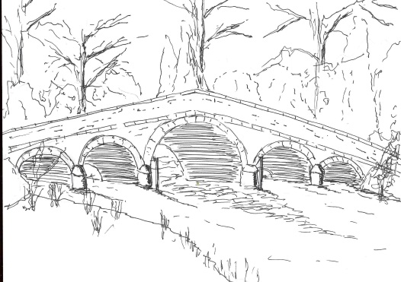
Skerne and Wansford Parish Council

Church Cottage, Wansford, Driffield, YO25 8NT
e-mail: jill_pick2001@yahoo.co.uk
tel: 01377 254741
336
Minutes of a meeting of the Skerne and Wansford Parish Council, which took place on Tuesday November 15 in Wansford Village Hall at 7.30pm.

- Present: Councillors Jackie Dobson, Ian Lamble, Lynn Stockwell, Neil Robson, Gill Grassam, Catherine Bristow, Ann Kitching, Sue Waites and ERYC ward councillor Paul Lisseter.

- Apologies: ERY councillors Jane Evison and Jonathan Owen.

- Public session: No members of the public present,

- Declarations of interest: Coun Dobson re item 8ii.

- To confirm the minutes of the meeting on September 20 as a true and correct record: Accepted with the alteration of Brennand to Bristow (10iii). Proposed Coun Dobson, seconded Coun Stockwell.

- To receive updates/information from ward councillors: Coun Lisseter mentioned the proposed closure of the Alfred Bean Hospital minor injuries unit, and said that it was important that people write in support of its retention, particularly as the town and area continued to grow with 2,600 homes were in the planning pipeline in Driffield. The clerk would write on behalf of the parish council objecting to the closure and fill in the on-line questionnaire.

- To dispose of any business remaining from the previous meeting and, if necessary, decide on a course of action:
- Site meeting re Skerne drains, junction at Wansford and blocked drains. The meeting had taken place but nothing was to be done. Coun Lisseter asked if he could meet councillors in Skerne at some point and get an overview of the situation.
- Dog fouling: noted that dog warden has sent several signs to be shared between the two villages, which councillors could place on lampposts. A member of the public had indicated to the clerk that he was obtaining CCTV footage of dog fouling offenders which he would bring to the parish council or send to the dog warden.
- Touring theatre event at village hall: About 50 people had attended a very successful evening resulting in a profit of £116 to be shared between the village hall committee and the parish council.
- ERYC/Lissett Windfarm grant for security equipment: three residents have taken up this offer. Noted.

- Finance:
- Noted: bank balances as at October 31 totalled £4474.24.
- Resolved: to set Wansford burial ground and Wansford Village Hall grants for 2017-18 at £275 each after reviewing the applications received. To defer a decision on any Skerne burial ground grant until the January meeting. Proposed Coun Grassam, seconded Coun Kitching.
- Resolved: to accept the budget for 2017-18 and set the precept at £3,500. Proposed Coun Grassam, seconded Coun Stockwell.
- Resolved: to devolve responsibility to clerk to pay Came & Co insurance premium – due before the end of the year. Proposed Coun Bristow, seconded Coun Grassam.
- Resolved: to reimburse clerk £77.99 for multipack of inks for the printer. Proposed Coun Dobson, seconded Coun Grassam.
- Noted: that Nafferton Millennium bus has been taken over by Holderness Area Rural Transport

- Administration and training:
- Grievance and disciplinary training, Driffield, November16 – no-one able to attend.

- Correspondence:
- ERNLLCA – there was a proposal to cap town and parish council precepts to 2 percent or £5, over which threshold a village referendum would be held. Noted
- Driffield School: twilight bus service: agreed: that not donation be given.

337
- Resolved: to consult in the newsletter re the removal of Wansford kiosk and opportunity to adopt, with a deadline of December 10, and request its removal if there was not a public will not only to retain but also to maintain the kiosk – cleaning, painting, etc. Proposed Coun Grassam, seconded Coun Kitching.
- PCSO Andy Milner re Neighbourhood Watch groups. Agreed: to defer this matter until January after publicity in the newsletter calling for a volunteer to be a group co-ordinator.
- Wansford Village Hall committee – request for a parish council representative to the committee. Coun Dobson agreed to continue, proposed Coun Stockwell, seconded Coun Grassam.
- Noted: ERYC Make time for winter leaflet.
- ERYC: Rough sleeper estimate – deferred. Clerk to complete.
- ERYC: ERY landscape character assessment – survey. Noted: no action.
- Noted: Barclays – business savings interest rates changing to 0%

- Matters requested by councillors:
- Planters in Wansford. Resolved: that Coun Stockwell spend some of the remaining Feoffees money on plants for the Nafferton Road and Whinhill Lock planters. Proposed Coun Waites, seconded Coun Stockwell.
- Removal of Skerne kiosk, painting of Wansford kiosk and both postboxes. Clerk to write to relevant parties re the removal of Skerne kiosk and painting of both postboxes.

- Highways: Clerk to write to Rob Brown re the Road Narrows sign in Nafferton road, flooding outside Rowan and the blackthorn on Skerne Road.

- Other correspondence: Clerk had received details of a Driffield Canal Steering Group meeting to take place on December 13 re opening the canal to boat trips by spring 2017. Additionally there was to be a broadband meeting in Foston Village Hall on November 30 at 6pm, to which all affected residents of Wansford and Skerne was invited.

- To receive reports from representatives:

- Items for next agenda: Skerne survey, Skerne burial ground grant

- Date of next meeting: January 17 at 7.30pm in Wansford Village Hall

